Workflow Functional Document

Application | NGERP - Centra
Workflow | Quote to Cash
Workflow Item Name | Commercial Discount

Description:

A Commercial Discount in an ERP system refers to a reduction in the price of goods or services offered to customers as part of a sales transaction. This discount is usually offered to encourage bulk purchases, reward loyal customers, or promote specific products

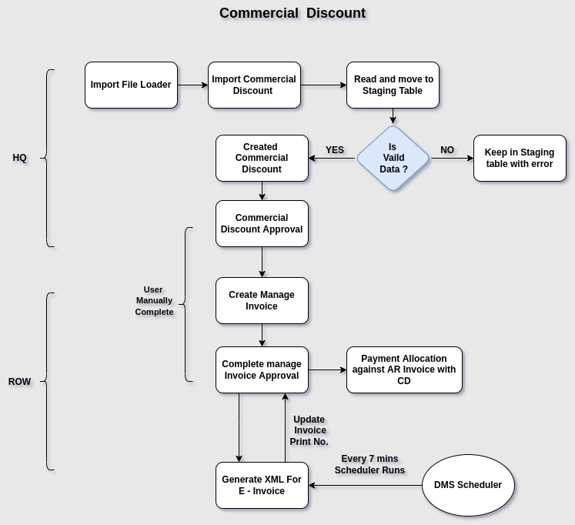
Workflow Process:

Business Rules:

- Import Commercial Discount file using the Import File Loader.
- The file name should start with 'ImportCommercialDiscount.csv.
- Import Data will be stored in the I_CommDiscMapping staging table.
- If the import file contains an error, it will remain on the staging screen. Otherwise, it will move to the
Commercial Discount screen in the Drafted state.
- In Commercial Discount, more than one physical document No cannot be created.
- Commercial Discount cannot be created for inactive GOA or inactive customers
- The Commercial Discount line SKU should be configured in the active state
- If the approval amount is exceeded, the Commercial Discount transaction cannot be approved
- Commercial Discount Approval screen to approve the transaction.
- Commercial Discount line not create Inactive Campaign.
- Create a Manage Invoice with the Commercial Discount document type and complete it using the Manage Invoice Approval screen.
- Generate E invoice XML for the Commercial Discount Invoice using Print Batch Invoice Form
- Use Payment Allocation Form to allocate the Commercial Discount invoice with the Promotion invoice
document type.

